=== ASSESSMENT FEEDBACK ===
The submission provides a thorough and insightful critique of the AI-generated lesson plan, identifying key flaws and offering practical improvements. The improved lesson plan demonstrates a strong understanding of effective teaching strategies, particularly in handling sensitive topics. The reflection shows thoughtful consideration of the changes made. However, more detailed integration of resources could enhance the improved plan.
==================================================

HISE 312 Assignment 1

Methodology: Critiquing and improving an AI-generated lesson plan.
Bianca Devereux 52615677

Part A: Critique
- Introduction/Conclusion
Flaw 1- The introduction phase makes use of a loaded question: “Who is mostly to blame for conflict in the Middle East?” that can be problematic. The question can lead to controversial and emotionally heated conversations by including the use of personal, political and religious matters. This can lead to alienation, heated debates and overall negativity in a diverse classroom. While a loaded question such as this can be used in the classroom, precautions and boundaries should be set before it is asked. I suggest that the question be more neutral and encourage source knowledge rather than personal opinions in order to remain sensitive in a highly diverse learning environment. For example, “What are some factors that contributed to the tensions in the Middle East?” This is a more neutral question, or to activate prior knowledge and subtly introduce the topic, ask “What do you understand about Nationalism?” [*1]
Flaw 2- Teacher reads a definition out of a textbook. This in itself is not wrong, however needs to be supported or supplemented with other definitions and examples. Only using one textbook definition can lead to a narrow or limited understanding; this can be fixed by using multiple sources for a fully diverse definition. After the definition is read, a detailed explanation should follow, as well as some type of informal assessment to measure understanding, as the whole lesson relies on a sound understanding of this complex term.
Flaw 3- Learners are encouraged to share their own personal beliefs and experiences. This could pressure students into sharing their private information or create tension and divisions based on different beliefs. While some debates and assessments can include personal beliefs, it needs to be approached with sensitivity and ground rules in order to minimise tension and protect privacy. An improvement would be to use sources, case studies and evidence rather than personal beliefs. This would encourage a discussion around perspectives and evidence rather than personal opinions and faith.
This also ties in to the discussion where the teacher corrects quickly and does not provide explicit ground rules. The teacher allows that only some students debate, and there is no record of the informal debate as an assessment. This is problematic in multiple aspects; firstly, having the teacher correct quickly takes away from the students' learning through their peers and the debate. It can be more beneficial to let the students learn through the process rather than quickly correcting them. An improvement would be to correct and provide general feedback after the debate. Secondly, not having explicit ground rules in a debate is problematic, especially when the debate includes personal beliefs. Thus, to correct this, the teacher should have explicit and clearly stated rules that ease tensions and protect beliefs or, as previously stated, have clear rules that limit the amount of personal opinions shared. Thirdly, the teacher should encourage or insist that all students participate unless there is a personal reason as to why and lastly, it is more beneficial to have some type of assessment. An informal assessment in terms of a debate still should have a type of measurement and recording.
Flaw 4- In the conclusion, there are multiple faults. The teacher quickly summarises the content, asks if they ‘understand’ and ‘if they agree’. Quickly summarising the contents of the lesson and only measuring their understanding by a quick question of whether they ‘understand’ does not adequately measure their students' understanding. Secondly, asking whether or not the students agree can create tension and again does not lead to an evidence-supported discussion. To improve this, the teacher should rely on a quick, measurable activity that can accurately measure students' understanding of the lesson.

- Teaching strategy and approach
Flaw 5- Teacher's lectures dominate the lesson. The issue with long lectures is that it encourages passive learning and engagement. Thus filling most of the lesson time (35 minutes) with a teacher-led lecture is an ineffective teaching method. To improve this, the lecture should be broken up into shorter sections that will keep students more engaged. Between these sections, the teacher could include some discussions, source analysis, group activities or any other activities that can scaffold understanding and just improve general enjoyment and engagement. This works to build various skills of history, such as' an interest in and enjoyment of the study of the past’ and ‘an understanding of historical concepts’. [*2]
Flaw 6- Heavy reliance on the textbook and note-taking. ‘Learners copy notes and read two textbook pages’ is not an active mode of learning and is also inadequate to explain such complex topics as Nationalism. The teacher’s main focus should not be on how quickly they can go through the notes, but on how well the notes can be used to help better understand the topic. Notes and the textbook should not be the only medium of learning. Only using one textbook can present only one perspective and provide a narrow or limited understanding. Thus, being said the teacher should use multiple sources/textbooks to present the learners with a well-rounded understanding of the topic. Also, the intent should not be to simply copy the notes but rather encourage the learners to make their own notes and write down what furthers their own understanding.
Flaw 7- The quick debate on ‘Which nationalism was more justified’ is very problematic, not only from a teaching point of view but with handling sensitive topics such as nationalism in the Middle East. In a diverse classroom, debates on sensitive topics should be approached with set ground rules to avoid personal tensions and alienation and the topic should be more neutral and evidence-based. For example, debate topics such as, ‘What similarities and differences do we see in Jewish and Arabic Nationalism?’ or ‘What are some factors that contributed to the conflict and rise of Nationalism in the Middle East?’ topics such as these create a more neutral and evidence-based debate rather than an argument based on personal opinion. Students should also not be encouraged to try to “win” the debate, rather the focus should be on gaining new knowledge and understanding different perspectives. [*4]
Flaw 8- Lesson aims do not include measurable action verbs. The lesson aims should be SMART tasks (specific, measurable, achievable, realistic and time-bound). SMART tasks ensure that the lesson aims are able to be measured and that learning is achieved. Simply saying that ‘learners will understand’ is not a definable task. Thus, this can not adequately measure understanding and does not give the teacher a definable understanding of their students' understanding of the topic. An example of an improvement could be ‘Learners will be able to define what Nationalism is’ this is a quantifiable task that gives the teacher a real understanding of their learners' understanding.
Flaw 9- Handling of sensitive or controversial topics, although this has been mentioned in other points, I believe it is something that needed to be its own point as well. This lesson does not adequately address the sensitive topic of the Middle East with enough understanding, forethought or rules to prevent tension and/or alienation. In this lesson, the topic is brought up casually to improve this ground rules should be introduced explicitly in the beginning of the lesson to limit the amount of personal faith that is shared without evidence, not doing this can create heated personal arguments that can create long-lasting tensions and cliques. Other than ground rules, specific distancing techniques can be used, while personal belief is important and can add in retention, it is important that it does not become overly personal and devoid of fact. Therefore, an improvement could be to have students examine sources and multiple perspectives rather than have a class debate on their own personal beliefs.
Flaw 10- Sequencing of learning. The lesson is quite scattered in terms of ordered thinking and learning. In terms of scaffolding and understanding it is best to go from lower to higher-order thinking. In the provided lesson, the activities jump from passive note-taking to active debating without any preparation in between activities to prepare students for the jump between the different levels of skills. Skills should be scaffolded from comprehension, source interpretation, evidence evaluation and then synthesis of an argument. Thus, there should be a progression from note-taking to a debate. As an improvement, the progression could go from defining, analysing sources, comparing sources and then synthesising an evidence-based debate. Bloom’s taxonomy should be used as a guide to how a progression of skills should be structured.

- Assessment and resources
Flaw 11- A multiple-choice quiz only focusing on definitions and dates is not an adequate type of assessment. This quiz does not assess historical skills or understanding; it only assesses Bloom's taxonomy level 1/low-order thinking skills, making it a poor type of assessment. An improvement could be short questions on a source or true or false questions on a source. Any of these works on source evaluation, which is a critical historical skill. [*3]
Flaw 12- The homework is again problematic. Asking a direct and opinion-based question on a sensitive topic is not sensible. Simply asking ‘Who is right in the Middle East conflict and why?’ takes away multiple perspectives and encourages learners to focus on only one perspective. An improvement could be to ask a neutral question and ask students to use sources, or the teacher could include sources. An example is “Using the sources provided, discuss the factors that led to the Middle East conflicts, make your understanding of Nationalism clear’. This would work on key historical skills by encouraging students to evaluate sources, see the past from more than one perspective and explain and appreciate the forces that shaped the past. [*5]

Part B: Lesson plan
Lesson plan on separate document
Source pack below

Learner worksheet
Example of sources (primary and secondary):
- Arab Nationalist Declaration (1918)
- Speeches by Sharif Hussein of Mecca
- Newspaper articles or cartoons from early 20th-century Arab press
- Theodor Herzl, “The Jewish State” (1896)
- Balfour Declaration (1917)
- Textbook summaries of Arab nationalism and Zionism
- Academic articles or excerpts from history books on nationalism in the Middle East.
- Maps of the Middle East before and after WWI
Guided questions:
- Who wrote this source and for what purpose?
- What is the main point/argument in the source?
- What similarities and differences do you see between Arab and Jewish nationalism?
Use:
- Students use individually or in group during 1&2 of teaching and learning phase
- These answers lead to the Venn diagram and structured conversation.
- Sources are used for homework paragraph as well
Venn diagram: (on the right is an example image)
- Similarities and differences in
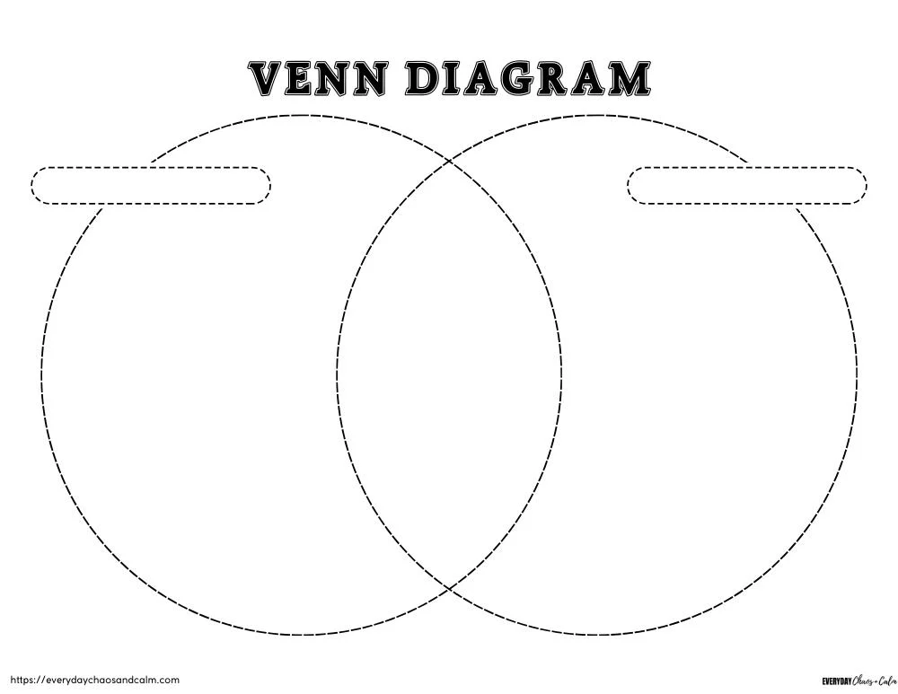
  - Goals
  - Methods
  - Beliefs
  - Context

Part C: Reflection
The key differences and changes made in the revised plan come down to sensitivity and student engagement. While the original lesson plan was not a ‘bad’ lesson, there were clear faults and problematic areas in which to improve. Whether or not these faults are due to AI and its inability to fully understand sensitivity and students' reactions, or if the faults mimic human ignorance. This assignment was eye-opening in understanding the complexities of teaching a sensitive topic in a diverse classroom and nation such as South Africa. Thus, why in the revision loaded language/questions were replaced with evidence-based neutral statements and how personal beliefs were distanced to mitigate alienation or tensions in the classroom. Another area for improvement was the teacher-centred explanations, long drawn-out lectures led to passive learning and minimal student engagement, which was improved by cutting down teacher explanations and adding more interactive and question-focused learning exercises. These changes encourage active learning and engagement while making sure that the learning environment is a safe place for all learners, regardless of their personal beliefs and faiths.

AI Log:
Chatgpt
Prompt: Suggest ways in which a history teacher could go about teaching and having a debate on sensitive topics such as the conflict in the Middle East
Reply: Teaching and debating sensitive historical topics like the Middle East conflict requires careful planning, empathy, and structure to ensure that learning is meaningful, safe, and respectful. Here’s a detailed approach a history teacher could take:
1. Preparation Before the Lesson
Establish Learning Goals: Be clear about what students should learn—e.g., understanding causes, perspectives, historical context, and consequences—rather than persuading them to take a side.
Contextual Background: Provide students with factual, neutral background information, timelines, and key events to avoid misconceptions.
Sensitivity Awareness: Acknowledge that some students may have personal or family connections to the conflict. Create a space that respects differing experiences.
Guiding Questions: Prepare open-ended, critical-thinking questions such as:
“What were the main historical causes of the conflict?”
“How have different communities experienced and responded to the conflict?”
“What role has the international community played?”
2. Structuring the Debate
Clear Rules of Engagement: Emphasize respectful discussion, active listening, no personal attacks, and evidence-based arguments.
Role-Playing / Perspectives Approach: Assign students to research and present different historical perspectives (e.g., Israeli, Palestinian, international viewpoints) to foster empathy and understanding.
Structured Format: Use a formal debate format (e.g., Oxford-style) with timed speaking, rebuttals, and a clear moderator role to maintain order.
3. Teaching Strategies
Case Studies and Primary Sources: Use documents, speeches, UN resolutions, and news articles to ground discussions in evidence.
Multimedia Resources: Maps, documentaries, and interviews can help students visualize historical events and their human impact.
Comparative Analysis: Compare one conflict with another historical conflict to explore patterns, causes, and consequences.
Small Group Discussions: Allow students to first discuss in smaller groups before sharing with the whole class—this encourages participation from quieter students and allows safe exploration of ideas.
4. Reflection and Debriefing
Guided Reflection: Ask students to reflect on what they learned, how their perspectives may have changed, and the challenges of understanding complex conflicts.
Emotional Check-In: Acknowledge emotions that arise and normalize thoughtful disagreement.
Critical Thinking Emphasis: Focus on analyzing causes, consequences, and multiple perspectives.
5. Assessment
Analytical Essays or Journals: Have students write about the different perspectives they encountered and the reasoning behind each.
Debate Participation Rubric: Assess students on research, respectful communication, and critical thinking rather than personal opinion.
6. Extra Tips
Neutral Language: Avoid loaded or biased terms.
Prepare for Controversy: Be ready to mediate conflicts or strong emotional reactions.
Encourage Empathy: Remind students that historical events affect real people, then and now.

Reference List:
EverydayChaosandCalm.com. (no date) Venn diagram template [Image]. Available at: https://everydaychaosandcalm.com/wp-content/uploads/venn-diagram/venn-diagram5.jpg (Accessed: 20 February 2026)

=== DETAILED ANNOTATIONS ===
[1] (PRAISE) Excellent identification of a problematic question and its potential impact.
Re: "The introduction phase makes use of a loaded question: 'Who is mostly to blame for conflict in the M..."
[2] (PRAISE) Good identification of passive learning issues due to lecture dominance.
Re: "Teacher's lectures dominate the lesson...."
[3] (SUGGESTION) Consider providing more detailed alternatives for assessment.
Re: "A multiple-choice quiz only focusing on definitions and dates is not an adequate type of assessment...."
[4] (PRAISE) Insightful critique of how debates on sensitive topics should be structured.
Re: "The quick debate on ‘Which nationalism was more justified’ is very problematic...."
[5] (PRAISE) Good identification of the issue with opinion-based homework questions.
Re: "The homework is again problematic. Asking a direct and opinion-based question on a sensitive topic i..."

